

**Base Plate Report**

Date: 2021/04/04

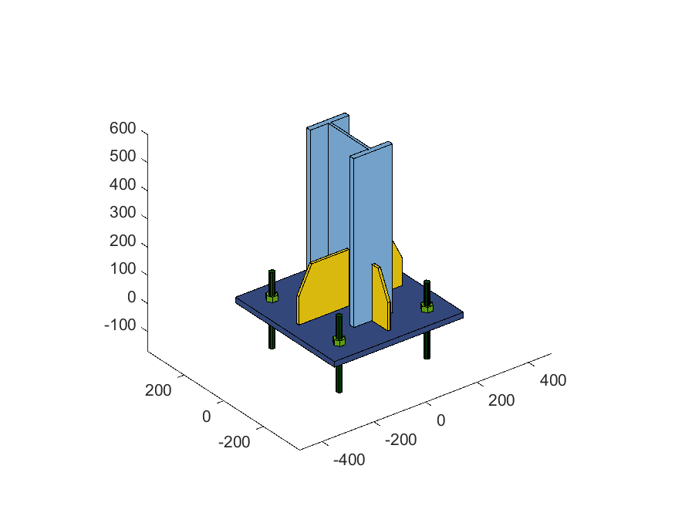

**Base Plate Data**

**Base Plate Width:** 50 cm

**Base Plate Height:** 50 cm

**Base Plate Thickness:** 20 mm

**Column Type:** I Shape

**Column Flange Width:** 15 cm

**Column Flange Thickness:** 20 mm

**Column Web Width:** 20 cm

**Column Web Thickness:** 10 mm

**Base Plate Force Type:** Manual Forces

**Anchor Diameter:** 20 mm **Number of Anchors:** 4

**Stiffeners Start Height:** 20 cm **Stiffeners End Height:** 10 cm

**Number of Stiffeners Y:** 1 **Number of Stiffeners X:** 1

**Design Preferences**

**Plate Fy:** 2400 kgf/cm2 **Weld Fue:** 4200 kgf/cm2

**Foundation Fc:** 250 kgf/cm2 **Foundation Ec:** 255002 kgf/cm2

**Anchor Fu:** 6000 kgf/cm2 **Anchor Es:** 2039432 kgf/cm2

**Design Codes:** AISC360-05, AISC341-05

**Forces**

**Pu:** 0 kgf

**Mu X:** 0 kgf.cm **Mu Y:** 0 kgf.cm

**Vu X:** 0 kgf **Vu Y:** 0 kgf

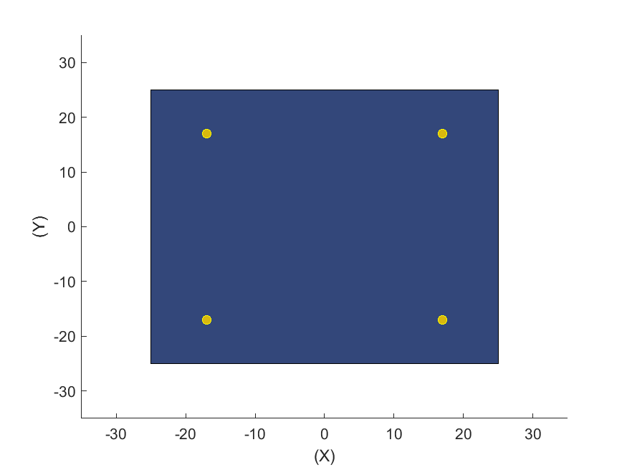

**Footing Bearing Stress Check**

**Fc =** 250 kgf/cm2

**A1 =** 2500 cm2

**A2 =** 10000 cm2

**ϕ =** 0.65

**Fp =** 0.85Fc√A2/A1 = 425.00 kgf/cm2

**Fup =** 0.00 kgf/cm2

**Fup/ϕFp = 0.000** **OK**

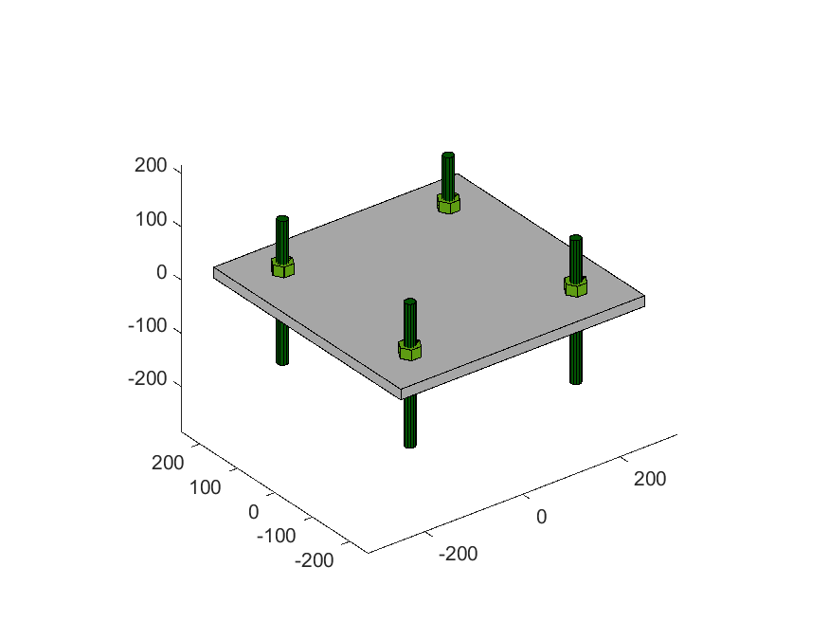

**Anchors Shear Stress Check**

**Anchors Fu =** 6000 kgf/cm2

**Anchors Diameter =** 20 mm

**Anchors Anb =** 314 mm2

**Anchors Result:**

**Vu =** 0.00 kgf

**ϕ =** 0.75

**Fnv =** 2700 kgf/cm2

**Rnv =** 8482.30 kgf/cm2

**Vu/ϕRnv = 0.000** **OK**

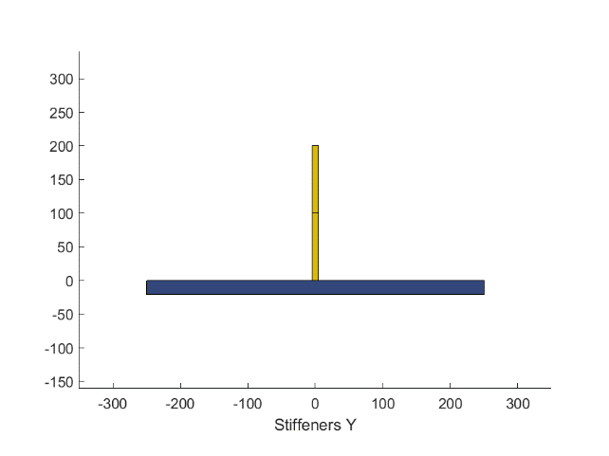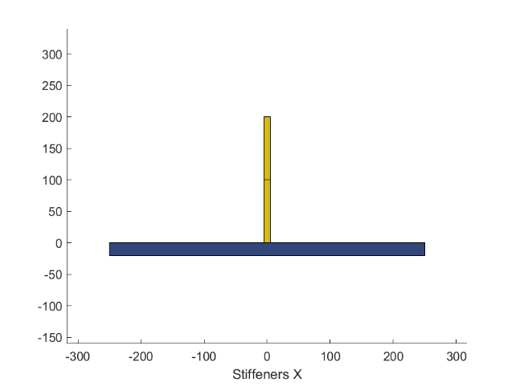

**Stiffeners Bearing Stress Check**

**Stiffeners Fy:** 2400 kgf/cm2

**Stiffeners Start Height:** 20 cm

**Stiffeners End Height:** 10 cm

**Number of Stiffeners Y:** 1

**Number of Stiffeners X:** 1

**ϕ =** 0.9

**Stiffeners X Result:**

**Mu =** 0 kgf.cm

**Mn =** 643200 kgf.cm

**Mu/ϕMn = 0.000** **OK**

**Stiffeners Y Result:**

**Mu =** 0 kgf.cm

**Mn =** 643200 kgf.cm

**Mu/ϕMn = 0.000** **OK**



**Stiffeners Shear Stress Check**

**Stiffeners Fy:** 2400 kgf/cm2

**Stiffeners Start Height:** 20 cm

**Stiffeners End Height:** 10 cm

**Number of Stiffeners Y:** 1

**Number of Stiffeners X:** 1

**ϕ =** 0.9

**Stiffeners X Result:**

**Vu =** 0 kgf

**Vn = 0.6FyAw =** 28800 kgf

**Vu/ϕVn = 0.000** **OK**

**Stiffeners Y Result:**

**Vu =** 0 kgf

**Vn = 0.6FyAw =** 28800 kgf

**Vu/ϕVn = 0.000** **OK**

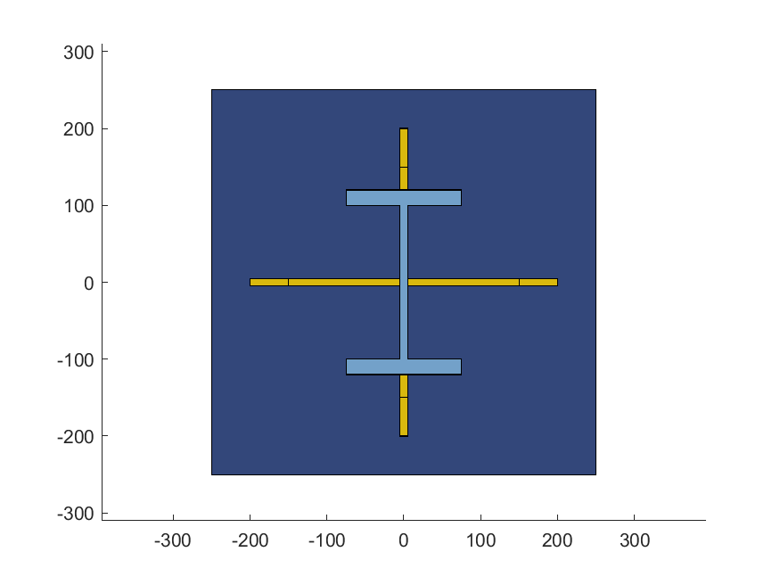

**Base Plate Panels Check**

**Base Plate fup =** 0.00 kgf/cm2

**Base Plate Fy:** 2400 kgf/cm2

**Edge Panel Results:**

**f =** 25 cm **c =** 25 cm

**e =** 5 cm

**ϕ =** 0.9

**Zp =** 35 cm3

**Mn =** ZpFy = 84852.81 kgf.cm

**Mu =** 0.5fupcfe = 0.00 kgf.cm

**Mu/ϕMn = 0.000** **OK**

**Base Plate Welds Check**

**Weld Fue:** 4200 kgf/cm2

**ϕ =** 0.75

**Stiffeners Weld Size to Column:** 8 mm

**Stiffeners Weld Size to Base Plate:** 8 mm

**Stiffeners Weld to Column Results:**

**Vux =** 0 kgf

**Vuy =** 0 kgf

**qax =** 0.00 kgf/cm

**qay =** 0.00 kgf/cm

**Aweldx =** qax/(0.707ϕFue) = 0.00 mm < 8 mm **OK**

**Aweldy =** qay/(0.707ϕFue) = 0.00 mm < 8 mm **OK**

**Stiffeners Weld to Base Plate Results:**

**Weld X Moment Inertia =** 8383 cm4

**Weld Y Moment Inertia =** 8383 cm4

**Mux =** 0 kgf.cm

**Muy =** 0 kgf.cm

**σ**vx **=** 0.00 kgf/cm2

**σ**vy **=** 0.00 kgf/cm2

**Aweldx =** (σvx×1cm)/(0.707ϕFue) = 0.00 mm < 8 mm **OK**

**Aweldy =** (σvy×1cm)/(0.707ϕFue) = 0.00 mm < 8 mm **OK**